---

1. Name of the Inventor(s)*

(Example — update based on actual inventors)

Anuraag Gupta
Divakar Vadlamani
Minnakshi Sharma

Zeople Corp.

---

2. Address and Citizenship of the Inventor(s)*

Example format:

Anuraag Gupta
Bangalore, Karnataka, India
Citizenship: Indian

Divakar Vadlamani
Bangalore, Karnataka, India
Citizenship: Indian

Minnakshi Sharma
Bangalore, Karnataka, India
Citizenship: Indian

---

3. Title of the Invention

AI-Augmented Human Recruitment Intelligence System Using a Large Recruitment Model (LRM™) for Real-Time Candidate Screening and Continuous Recruiter Skill Intelligence

Alternative shorter title (optional):

AI–Human Collaborative Recruitment Screening and Intelligence System

---

4. Problem Solved by the Invention*

Recruitment screening today is largely dependent on the skill, experience, and domain expertise of individual recruiters. Many recruiters are not subject matter experts in the complex technical or functional roles they are tasked with screening. As a result, screening calls are often inconsistent, superficial, or inaccurate, leading to poor candidate evaluation, wasted interview cycles, and suboptimal hiring outcomes.

Existing technologies attempt to solve this problem through tools such as Applicant Tracking Systems (ATS), AI sourcing tools, and automated AI bots that conduct screening interviews. However, these approaches have significant limitations:

ATS platforms primarily act as data storage systems and do not provide intelligence for candidate evaluation.

AI sourcing tools automate candidate discovery but do not improve the quality of screening conversations.

AI chatbots or automated interview systems remove human interaction, often resulting in poor candidate experience and limited contextual understanding.

Recruiters still lack real-time guidance to ask the right questions during screening calls.

Furthermore, there is currently no system that simultaneously improves both candidate evaluation and recruiter capability through structured intelligence derived from recruiter–candidate conversations.

The problem addressed by this invention is therefore two fold:

1. Improving the accuracy and consistency of candidate screening performed by recruiters who may not be domain experts.

2. Continuously improving recruiter skills and effectiveness through AI-driven analysis of their screening conversations.

This invention solves these problems by introducing a system where artificial intelligence collaborates with recruiters in real time during screening calls, dynamically guiding questions, evaluating candidate responses, generating candidate intelligence, and simultaneously producing recruiter intelligence for continuous improvement.

---

5. Brief Description of the Invention*

The invention describes a computer-implemented recruitment intelligence system in which artificial intelligence collaborates with a human recruiter during live candidate screening interactions.

The system is powered by a domain-specific model referred to as the Large Recruitment Model (LRM™), which is designed to understand job roles, candidate profiles, screening conversations, and recruiter behavior.

In operation, the recruiter uploads a job description and selects a candidate profile. The system analyzes both inputs and constructs a contextual intelligence framework representing the requirements of the role and the attributes of the candidate.

The recruiter then initiates a live screening call with the candidate using the system. During the conversation, the AI listens to the interaction and dynamically generates screening questions tailored to the job description, the candidate profile, and the ongoing responses provided by the candidate.

These questions are displayed in real time on the recruiter’s interface, enabling the recruiter to ask relevant functional, technical, and behavioral questions even if they are not experts in the role being screened.

As the candidate responds, the system evaluates the responses in real time and generates structured scoring and evaluation metrics that are visible to the recruiter during the call.

After the call concludes, the system automatically generates a comprehensive candidate assessment report including:

- Candidate skill evaluation

- Role fit analysis

- Strengths and gaps

- Screening score and evaluation summary

In addition to candidate evaluation, the system records and transcribes recruiter-candidate interactions. These interactions are analyzed to generate recruiter performance intelligence. The system periodically produces feedback and coaching recommendations for recruiters based on communication quality, questioning ability, candidate engagement, and other behavioral indicators.

Through this mechanism, the invention simultaneously generates talent intelligence and recruiter intelligence, creating a continuous improvement loop that enhances both hiring outcomes and recruiter capability over time.

---

6. Detailed Description of the Invention

The invention consists of several interacting components that together form an AI-assisted recruitment intelligence system.

---

1. Job Description Intelligence Module

The recruiter begins by uploading a job description into the system.

The system processes the job description using the Large Recruitment Model (LRM™) to extract structured role intelligence, including:

Required skills

Experience requirements

Functional competencies

Technical competencies

Role expectations

This information forms a Role Intelligence Map, which becomes the basis for candidate screening.

---

2. Candidate Profile Intelligence Module

The candidate’s resume or profile is uploaded or selected from an existing candidate database.

The system analyzes the candidate profile to extract:

Skill claims

Work experience

Career progression

Technology exposure

Role alignment signals

This information is mapped against the Role Intelligence Map to determine areas of alignment and potential gaps.

---

3. AI–Human Collaborative Screening Interface

The recruiter initiates a live screening call with the candidate through the system interface.

Unlike automated AI interviews, the recruiter remains the primary human interface communicating directly with the candidate.

During the call, the AI system continuously analyzes the conversation and generates suggested questions that are displayed on the recruiter’s screen.

These questions may include:

Technical questions

Functional questions

Scenario-based questions

Clarification prompts

Follow-up questions based on candidate responses

The AI dynamically adapts the questions depending on the responses provided by the candidate.

---

4. Real-Time Candidate Response Evaluation

As the candidate responds to the recruiter’s questions, the AI system evaluates the responses in real time across multiple dimensions such as:

Relevance

Accuracy

Depth of explanation

Communication clarity

Consistency with prior responses

The system generates real-time scoring and evaluation indicators that assist the recruiter in understanding the candidate’s capabilities.

---

5. Post-Call Candidate Intelligence Report

At the conclusion of the call, the system automatically generates a detailed candidate assessment report including:

Skill-level scoring

Strengths and weaknesses

Role suitability assessment

Risk indicators

Overall candidate score

This report assists recruiters and hiring managers in making informed decisions about candidate progression.

---

6. Candidate Feedback Intelligence (Optional)

The system can optionally generate candidate improvement insights, identifying areas where the candidate may improve their knowledge or communication.

This enhances candidate experience and provides constructive feedback.

---

7. Recruiter Intelligence and Coaching Module

All recruiter-candidate interactions are recorded and transcribed (subject to consent).

The system analyzes these conversations to evaluate recruiter performance using a predefined framework including:

Questioning effectiveness

Communication clarity

Empathy and tone

Listening ability

Candidate engagement

Negotiation and persuasion ability

Based on these analyses, the system periodically generates recruiter feedback and improvement plans.

---

8. Continuous Learning Loop

The system continuously learns from:

Recruiter decisions

Candidate outcomes

Screening results

Feedback data

This creates a recurring intelligence loop that improves both candidate evaluation accuracy and recruiter performance over time.

---

7. Diagrams / Figures (Pratik to add here)

Possible diagrams include:

1. System Architecture Diagram

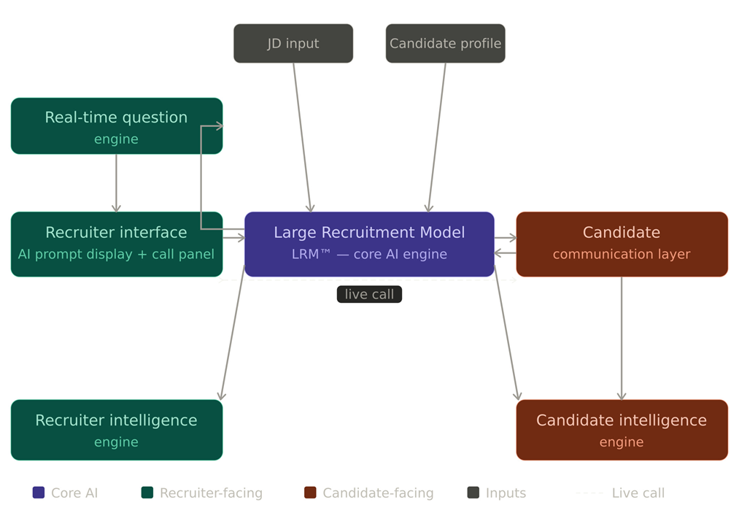

2. Workflow Diagram

Assisted Calling Workflow:
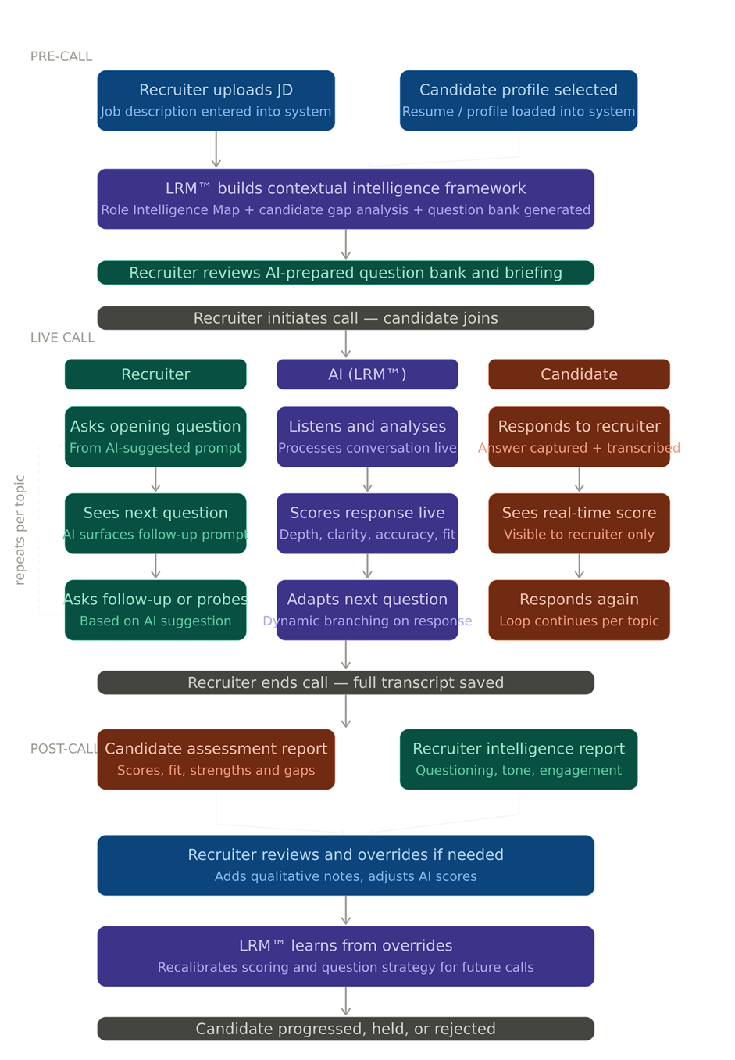

Recruiter Coaching Workflow:

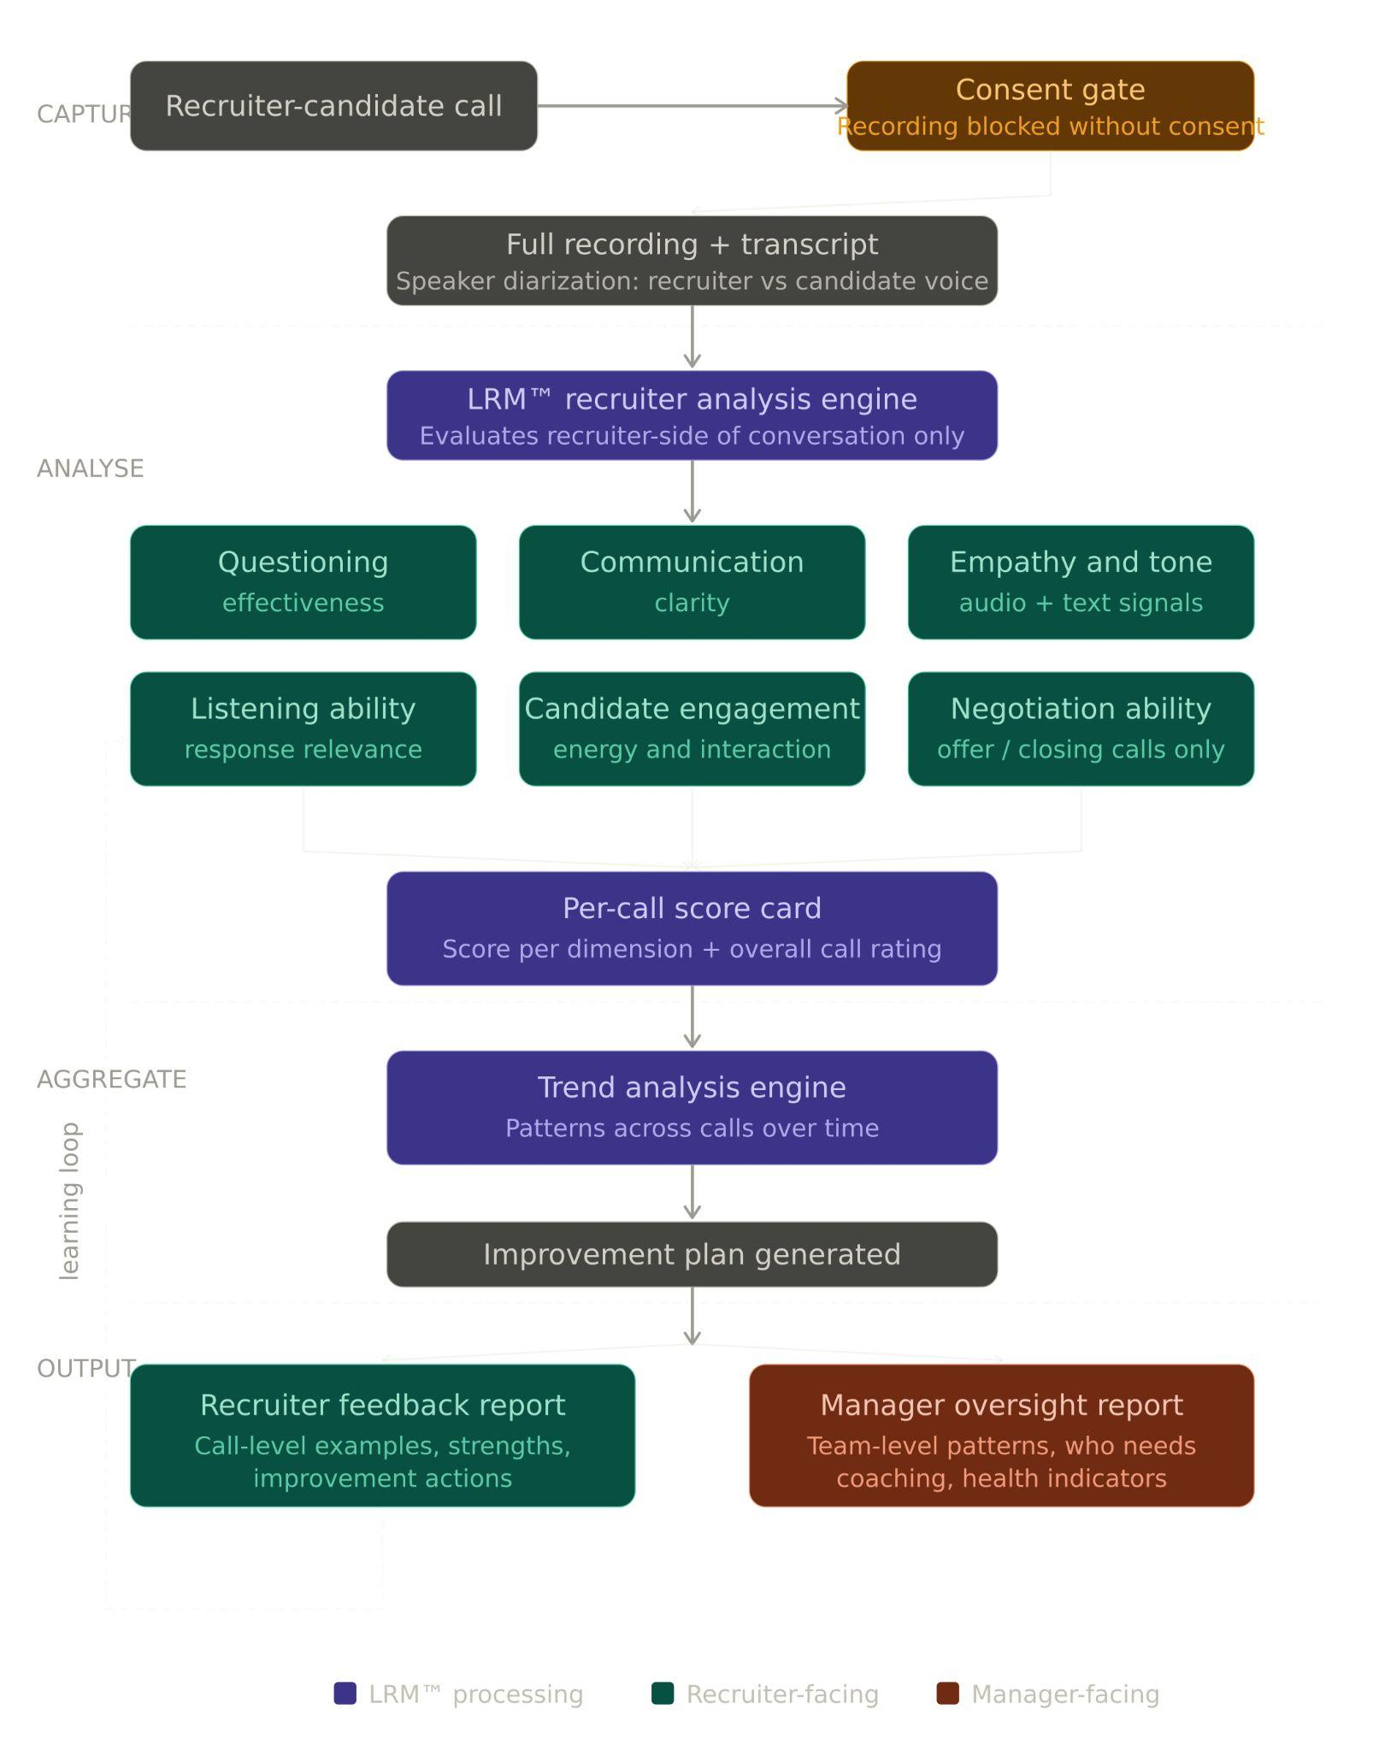

---

8. Literature / Prior Art (If Any)

Existing technologies include:

Applicant Tracking Systems (ATS)

Automated AI interview bots

AI sourcing tools

Video interview platforms

However, these systems either automate parts of the hiring process or provide static assistance. None provide real-time AI guidance to recruiters during live candidate screening while simultaneously generating recruiter performance intelligence and coaching loops.

The combination of:

real-time AI-guided human screening,

dynamic question generation,

simultaneous candidate and recruiter intelligence generation,

and continuous recruiter coaching

represents the novel aspect of this invention.

---

Final Ownership Declaration

This invention is developed under and assigned to:

Zeople Corp.

All intellectual property rights arising from this invention are intended to be owned by Zeople Corp.

---

